**MANAGING FINANCE**

**Student Number:**

**Module Code: UMAD47-15-M**

**Word Count: 2033**

**Executive summary**

Financial performance evolution is the most important activity of the financial analyst to determine the overall growth of the company in a particular financial year. It is also necessary to understand the organisational efficiency of a company and its effectiveness in the market. In this report, Next Plc is chosen as the balance sheet and income statement of the company for the financial year, 2019-2020 and 2020-2021. Three Types of ratios were calculated such as profitability, liquidity and efficiency. All these three aspects are covered with various subtypes’ ratio graphical representation.

Table of Contents

Option A 4

Introduction 4

Data Analysis 5

Findings, analysis, Interpretation of result 8

Conclusion 13

Reference List 14

# Option A

## Introduction

Financial analysis can be described as the evaluation of business finance related transactions in order to determine the suitability of the project and overall performance. For financial analysis, revenue, profit, capital efficiency, Liquidity and operational efficiency are considered. In order to effectively evaluate financial performance, a financial analyst required quantitative skills, adeptness and problem-solving ability. This report will contain a financial analysis of Next PLC and various ratios will be calculated in this regard. Next Plc, is one of the most popular multinational clothing brands currently operating from the United Kingdom. The founder of this company is Josef Hepworth. This company has adopted the operational approach to introduce flexibility and minimise the negative effects of retail sales.

**Aims and Methodology**

This report aims to understand the financial performance of Next Plc for the financial period 2019-20 and 2020-21.

All the information requested for the ratio analysis will be collected from the annual reports of this company for the above-mentioned years (Nextplc.co.uk, 2021). The ratios will be presented in table format and graphical representation will also be included in the report as per the requirement.

| **Specific** | The specific objective of preparing this report is to understand the liquidity, Profitability and Efficiency of Next PLC. |
| --- | --- |
| **Measurable** | It is also necessary to determine whether the company can achieve the targeted profit rate (Youtube, 2022). |
| **Achievable** | Another major objective of preparing this report is to determine the overall financial position in the last two years. |
| **Relevant** | This report will also be relevant in the current context because it can help the management to determine the growth rate of the company. |
| **Time-bound** | This report is also necessary for the higher authority of the company to set different objectives for various periods and determine the financial backing of every objective (Youtube, 2022). |

**Table 1: SMART Objectives**

## Data Analysis

**Profitability Ratio**

| ***Gross profit margin*** | ***2019-2020*** | ***2020-2021*** |
| --- | --- | --- |
| Gross profit | 1247.9 | 1640.5 |
| Revenue | 3284.1 | 3997.5 |
| Answer | 37.99823 | 41.0381488 |
|  |  |  |
| ***Net profit margin*** | ***2019-2020*** | ***2020-2021*** |
| Net profit | 286.7 | 610.2 |
| Revenue | 3284.1 | 3997.5 |
| Answer | 8.729941 | 15.2645403 |
|  |  |  |
| ***Return on Investment*** | ***2019-2020*** | ***2020-2021*** |
| EBIT | 444 | 854.3 |
| Capital employed | 1900.3 | 2282 |
| Answer | 23.36473 | 37.4364592 |
|  |  |  |
| ***Return on Assets*** | ***2019-2020*** | ***2020-2021*** |
| Net profit | 286.7 | 610.2 |
| Total assets | 3758 | 3673.3 |
| Answer | 7.629058 | 16.611766 |

**Table 2: Profitability ratio**

| **Current ratio** | ***2019-2020*** | ***2020-2021*** |
| --- | --- | --- |
| **Current assets** | **2288.6** | **1955.4** |
| **Current Liability** | **1196.8** | **949.8** |
| **Answer** | **1.912266** | **2.05875** |
|  |  |  |
| **Acid test ratio** | ***2019-2020*** | ***2020-2021*** |
| **Current assets** | **2288.6** | **1955.4** |
| **Current Liability** | **1196.8** | **949.8** |
| **Inventory** | **536.9** | **527.6** |
| **Answer** | **1.463653** | **1.50326** |

**Table 3: Liquid ratio**

| **Accounts receivable** | ***2019-2020*** | ***2020-2021*** |
| --- | --- | --- |
| **Credit sales** | **3284.1** | **3997.5** |
| **Average Accounts Receivable** | **1108** | **1315.3** |
| **Answer** | **2.963989** | **3.03923** |
|  |  |  |
| **Inventory turnover ratio** | ***2019-2020*** | ***2020-2021*** |
| **COGS** | **2231.7** | **2584.2** |
| **Average Inventory** | **536.9** | **527.6** |
| **Answer** | **4.15664** | **4.89803** |

**Table 4: Efficiency ratio**

## Findings, analysis, Interpretation of result

In order to analyse the financial statements of Next Plc, a ratio analysis method has been followed in this report. It is important to this company because, with ratio analysis, the Management of this organisation can understand liquidity position, determine the profitability aspect and evaluate the efficiency of the company (Youtube, 2022). The major advantages of ratio analysis to this organisation are that it helps in validating the investment decision of the firm and simplifies the hidden meaning of the accounting statements. Both internal and external stakeholders of Next Plc will be beneficial with the results of the ratio analysis because they will be able to protect their interests in the company (Shakil and Hasan, 2021).

***Profitability ratio***

The profitability ratio is the most important part of the ratio analysis because it shows the profit earning capacity of Next Plc. In this category of ratio analysis, four types of ratios are calculated such as

* Gross profit margin
* Net profit margin
* Return on investment
* Return on assets

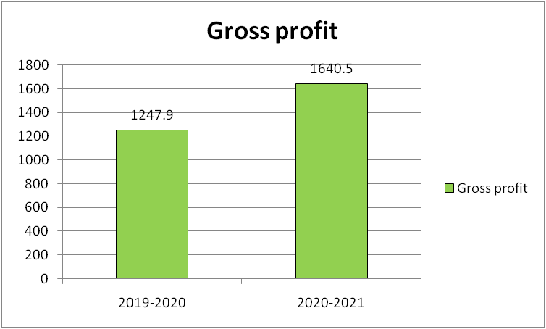

**Figure 1: Gross Profit**

(Source: Self-created)

The above figures represent the gross profit of Next Plc, in the financial year 2019-20 and 2020-21. It also shows the efficiency of the organisation in handling the core operation. The gross profit of the company is calculated by subtracting the cost of sales from the revenue, it shows the capacity of Next Plc, in earning profit from the main business. In the retail sector of the United Kingdom, the average rate of gross profit margin is around 40% to 50% (Hannila *et al.* 2019). From the table of gross profit margin, it can be ascertained that in the financial year 2019-20, this organisation could not generate a substantial amount of gross profit to reach the market average. The major reason for the failure is the pandemic situation in the last quarter of this particular financial year. However, from this table, it can also be observed that Next Plc was able to recover from the previous year. In that year, the gross profit margin was more than the market average. So, from the gross profit margin of the company can be said that the overall operational structure of this organisation is quite strong to compete in the market (Hirdinis, 2019).

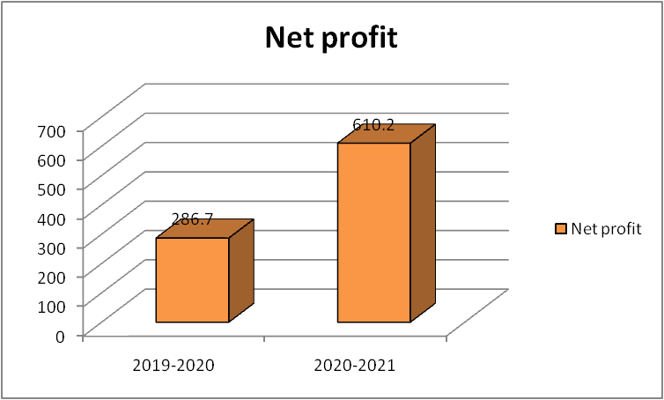

**Figure 2: Net profit**

(Source: Self-created)

The above figure represents the absolute value of net profit of the financial year 2019–20 and 2020-21 of the Next PLC. Net profit margins is one of the most important profitability ratios that are used to calculate the ultimate profit-earning capacity of this organisation after meeting the direct and indirect financial expenses. From this figure has been ascertained that the net profit of Next Plc, was lower in the financial year 2019-20. The major reason for such a declining trend in net profit was the Economic slowdown in the country. For this reason, there was a huge decrease in the cells and it was quite a challenge for the company to recover the switch financial expense in the year. However, from the net profit reported in the financial statement of this company, it can be stated that the popularity and the overall acceptance of the brand among the customers are the main reason for this huge success even in this challenging time (Fajaria and Isnalita, 2018). The market average net profit margin for the retail fashion industry is around 12 to 15%. In the last financial year, Next Plc was able to generate more net profit margin than the market average.

The two most important profitability ratios which are calculated in this report are return on investment (ROI) and return on assets (ROA). These two ratios are very important to the external stakeholders such as investors of the company because they are useful in determining the suitability of the investment in the company (Sommers and Zhang, 2018). The major objective of calculating the return on investment of Next Plc is that it is useful in calculating the return on the capital employed and investors can understand the return at the end of the financial year in respect of their investment. From the table of ROI, It can be observed that in the two selected financial years, Next Plc Was able to provide a positive return to the investor in the last financial year, 2020-21, Rate of return was more than 35%. From the ratio of ROA, It has been observed that the efficiency of the management of Next Plc, improves in managing the assets and generating profit from that in the financial year 2020-2021.

***Liquidity ratio***

The liquidity ratio is another most important aspect of ratio calculation because it shows the liquidity structure of the company (Robinson, 2020). In this report, two types of liquidity ratios are calculated such as current ratio and acid test ratio. The current ratio of Next PLC is calculated by dividing the current assets by current liabilities. The ideal rate of the current ratio for the retail fashion industry in the United Kingdom is 1 to 1.5. From the table of current ratio, it has been observed that the liquidity position is quite satisfactory according to the market average. It can be said that, even in the pandemic situation, the liquidity position of this company remained intact, and the balance of current assets was always more than the balance of the current liability. So, it can be said that Next Plc can meet the short-term obligations very effectively. Another ratio that is calculated is the asset test ratio (Dowdell *et al.* 2020). This ratio is used to show the immediate capacity of the company to pay the short-term obligations. The Ideal range of acid test ratio is 1. So it can be concluded that Next Plc, has the efficiency to meet the short-term obligation even if the value of inventory is not considered.

***Efficiency ratio***

The efficiency ratio of Next Plc shows the effectiveness of the company in handling the liabilities and assets of the company internally. The calculation of accounts receivable ratio and inventory turnover ratio shows the operational efficiency of this organisation. From the ratio of account receivable, it can be determined that Next Plc is quite efficient in collecting the total amount due from the dishes within the specified time limit (Kadim *et al.* 2020). In the financial year 2020-21, Next PLC was able to collect the due amount more effectively than the previous year. In the retail industry of the UK, the ideal range of receivable turnover ratio is 7.8. In this respect, it can be observed that this company is falling behind the market average. On the other hand, the inventory turnover ratio is calculated in this report to determine the effectiveness of Next Plc, regarding the Inventory management of the company and revenue generation. In the current business state of this country, the ideal range of inventory turnover ratio is 5 to 10. From the table of inventory turnover ratios, it has been observed that the value of this ratio is below the market evidence and from this, it can be ascertained that this organisation needs to take appropriate measures to sell the products to the customers. The lowest value of inventory turnover ratio depicts the lack of effectiveness of Next Plc, in selling its inventory.

In this report, three aspects of the financial position of Next Plc are considered such as liquidity, profitability and efficiency. From the overall analysis of the balance sheet and income statement, it can be said that profitability and the liquidity position of the next PLC are quite satisfactory. However, the management of this organisation needs to take appropriate measures to improve the efficiency of the company in handling account receivable and inventory (Kliestik *et al.* 2020).

***Recommendations***

* It is recommended to the management of Next Plc, to take immediate actions regarding the marketing and advertisement of the company. It will help this organisation to improve the inventory turnover ratio.
* It is also recommended to focus on New Market development and improvement in the product quality so that the customers can rely on the brand more than the competitors.
* From the profitability ratio of the company, it has been observed that the net profit of the company is slightly above the market average. In order to improve the net profit margin, the most effective way is to control the direct and indirect costs of the company. If the management of this organisation can control the indirect cost, then Next PLC will be able to earn more profit after tax and it will also satisfy the investors.
* Even though the liquidity position of the company is quite satisfactory, it is recommended to the management of Next PLC to set aside at least 10% of the profit as a contingency fund to deal with uncertain future events.

## Conclusion

From the overall analysis in the report, it can be concluded that the financial position of this company is quite stable even after the economic lockdown due to covid-19. The profitability and liquidity position of Next PLC is more than the market average and it shows the internal effectiveness of the organisation and the efficacy of the management. However, it is also important to focus on inventory management to stay ahead of the competitors in the long run in the retail fashion industry. From the overall performance of Next PLC, it can be stated that this organisation has the potential to grow in the future and provide meaningful returns to the investor.

## Reference List

Dowdell, T.D., Klamm, B.K. and Andersen, M.L., 2020. INTERNAL CONTROLS AND FINANCIAL STATEMENT ANALYSIS. *Journal of Theoretical Accounting Research*, *15*(2).

Fajaria, A.Z. and Isnalita, N.I.D.N., 2018. The effect of profitability, liquidity, leverage and firm growth of firm value with its dividend policy as a moderating variable. *International Journal of Managerial Studies and Research (IJMSR)*, *6*(10), pp.55-69.Easton, P.D., McAnally, M.L., Sommers, G.A. and Zhang, X.J., 2018. *Financial statement analysis & valuation*. Boston, MA: Cambridge Business Publishers.

Hannila, H., Koskinen, J., Harkonen, J. and Haapasalo, H., 2019. Product-level profitability: Current challenges and preconditions for data-driven, fact-based product portfolio management. *Journal of Enterprise Information Management*.

Hirdinis, M., 2019. Capital structure and firm size on firm value moderated by profitability.

Kadim, A., Sunardi, N. and Husain, T., 2020. The modelling firm's value is based on financial ratios, intellectual capital and dividend policy. *Accounting*, *6*(5), pp.859-870.

Kliestik, T., Valaskova, K., Lazaroiu, G., Kovacova, M. and Vrbka, J., 2020. Remaining financially healthy and competitive: The role of financial predictors. *Journal of Competitiveness*, *12*(1), p.74.

Nextplc.co.uk, (2021), Annual report, Available at: <https://www.nextplc.co.uk/~/media/Files/N/Next-PLC-V2/documents/2021/annual-report-and-accounts-jan21.pdf> [Accessed on: 23/01/2022]

Robinson, T.R., 2020. *International financial statement analysis*. John Wiley & Sons.

Shakil, M. and Hasan, M., 2021. Profitability analysis of RTM company based on their major operation.

Youtube, (2022), Available at: [www.youtube.com/watch](http://www.youtube.com/watch)?v=8XEMMGMCEV07list=PLPTTY0rZDyzAqAL8TRGRQCtnH3qoHPABz&index=22 [Accessed on: 23/01/2022]

Youtube, (2022), Available at: hiips://[www.youtube.com/play&yIist?list=PLPTTYOrZDyzAqAL8TRGRQCtnH3qQHpaBz](http://www.youtube.com/play&yIist?list=PLPTTYOrZDyzAqAL8TRGRQCtnH3qQHpaBz) [Accessed on: 23/01/2022]

Youtube, (2022), Available at: [www.youtube.com/watch?v=WhMyUW01](http://www.youtube.com/watch?v=WhMyUW01) [Accessed on: 23/01/2022]