**Case study**

**Approaches of health**

Table of Contents

Introduction 3

Two contrasting definitions of health and ill health 3

Two different models of health and ill health 4

Three contrasting sociological perspectives on health 6

The factors of reaction of people on ill health 7

Recommendation 8

Conclusion 8

# Introduction

Health is the most essential part of any human being. Mainly health is the balance of physical support and mental support of the body for a living creature. Good health is also supported by the well balanced social atmosphere. A good health is maintained by a good immunogenic power of a human being which protects the body from the attack of virus or any diseases. An ill health condition of a person easily distracts him from his daily lifestyle and his work culture. The absence of diseases is the best strength of good health. A good condition of health states the good power of immunity in the cells of the body. The strength of a good health is also maintained with a balance of good mental power of health and physical power of health. Not only that, the hygienic social health is also one of the effective parts of good health. The balance between good physical, mental and social health is the best sign of good health for a person.

# Two contrasting definitions of health and ill health

***Health:*** Health is one of the critically important conditions of the life of human beings. Good health is the key to success in any field of life for a person. Good health comes from the good immunogenic power of a person. The immunity power of a person helps him a lot to build the power of resistance in the body of the person to fight against the attack of viruses and diseases (Martelli, 2017). The power of immunity makes the cells of the body so strong for not to catch any types of viral infections on the body. As well as the psychological mental health of a person can ease the pressure of the problems of lives by which the person can build a strong power of connections between the physical tools of the body with the psychological mental co relational factors. Not only that, the good condition of health also depends on the good condition of social health. The condition of the social health is always a key factor to maintain a good condition of health. So the good combination of biological health of physics, psychological mental health as well as social health is the pillars of a compact good condition of health. In this case study, the health condition of Emma Jones was good when the three health conditions of her life were maintainable. The physical health of her was good when she was not involved in any addiction and the psychological mental health was in good position till her divorce with her husband. So the conditions of good health satisfied her with her life.

***Ill health:***  In another view, an ill health is a negative side of the health for a person. The ill health of a person can be a distraction factor in any field of the lifestyle. A bad immunity power of the body increases the chances of biological illness for a person. An ill condition of a person has not any power of resistance. The lack of resistance power of a person helps the viruses to easily attack the body and spreads its diseases over the body (Helvaci et al. 2018). The ill health condition of a person describes the low immunogenic power of his body. The weakness in mental power is one kind of sign of bad psychological mental health. A weak condition of mental health is not able to maintain the balance with the biological health of the body. The misbalances in the communicational factors between biological health of physics and psychological mental health are a sign of ill health. Apart from this, social health is a factor in ill health. The bad condition of social circumstances is a part of ill health. The misbalanced of social wellness also increases the ill health of a person. An unhygienic social health can easily increase the rate of viruses by which the illness of health is increased. So the misbalances of this physical, mental and social health are the sign of ill health for a person. In this case study the ill health occurred in Emma’s life when her physical and mental balances were lost. The addiction of smoking and drinking and also the divorce with her husband destroyed the good physical and mental health of Emma’s life. That is why the ill health condition of Emma clarified the reasons of ill health.

# Two different models of health and ill health

**Model of health:** The model of good health is the well combination of biological, psychological and social health of a person. The biological health is the type of physical health and the psychological health is the type of mental health. Mainly the model of the health constructs by the well balanced of these three conditions. The balance between the biological health of physics and the psychological mental health is so important in the strength of health for a person. The better power and the relation of communication between physical and mental health is the base for a good health of a person. The biological health is the base of this model. A well groomed biological health of physics can increase the fighting power against any kind of viruses and diseases. In another side the psychological health eases the pressure of a person and helps him to build mental development (Savenkova et al. 2019). Social health is the essential part of the model of health. Mainly the model of health is the bonding of these co relational health factors. In this case the biological health condition and the psychological health conditions of Emma were good when she did not involve herself into any kind of addiction and the divorce did not occur in her life. The past life of Emma was in the condition of model health.

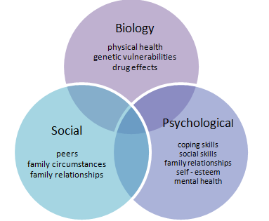

**Figure 1: Model of health**

(Source: https://upload.wikimedia.org/wikipedia/commons/6/6f/Biopsychosocial_Model_of_Health_1.png)

**Model of ill health:** The model of ill health is the misbalance of the factors of health. The illness of health comes from the illness of biological health and the psychological health. As well as it also comes from the disturbance of social health. The lack of immunity power brings the illness of biological health (Furqan et al. 2019). The habits like smoking, drinking are the factors of the illness of biological health. In this case the habits of smoking and drinking of Emma Jones helped to bring the illness of biological health. The main factor of the illness of psychological health is depression. A mental depression can easily damage the good psychological health of a person. As the divorce conducted in Emma's life, the psychological illness occurred into her life. The unhygienic health of society is a factor of ill health by which the balance between these health conditions is tolerated. In this case study, the model of ill health is totally satisfied by the life of Emma Jones.

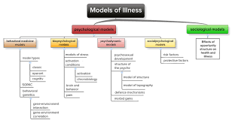

**Figure 2: Model of ill health**

(Source: https://encrypted-tbn0.gstatic.com/images?q=tbn:ANd9GcRUWiIBeja4PRSnSXOyWoVClQvezQZGKOhbqQ&usqp=CAU)

# Three contrasting sociological perspectives on health

**Structural Functionalism:** The society has a big existence in the good maintenance of health. The culture of the society as well as the structure of the society has a major influence in the good health for a person. The structural functionalism of society helps to maintain the good health condition for a person. The ability of the society is so essential to maintain a hygienic social health. In another view, the functionalism of society helps in the bonding of the relationship between the physician and patients (Wendt et al. 2020). Mainly the structural functionalism of society is the base of the wellness of social health for a person. In this case study, Emma was affected by the structural functionalism of society as her neighbour was ready to collect her two youngest children.

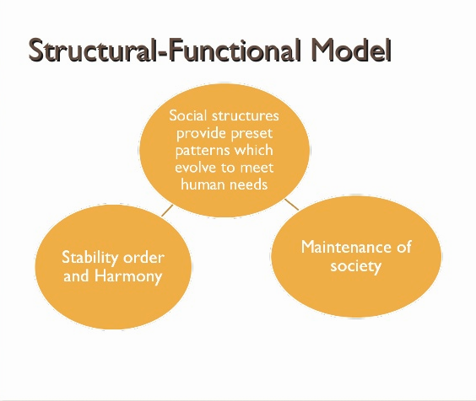

**Figure 3: Structural Functionalism model**

(Source: https://image.slidesharecdn.com/sociologicaltheoriesandtheeducationsystem-140115201436-phpapp01/95/sociological-theories-and-the-education-system-25-638.jpg?cb=1389816946)

**Symbolic Interactions:** The symbolic interactions are one kind of the perspective of sociological health. The symbolic interactions based on the wellness and illness of the health which are constructed by the society. It is focused on this specific appearance by society. The symbolic interactions cause the specific symptoms of illness of the society. It approaches the health and illness which are constructed by the interference of society. The symbolic interactions maintain the bonding between the patients and the professionals of healthcare services. It has some little or none issues over biological health and psychological health (Wang and Geng, 2019). Otherwise it is totally based on the issues of social health and ill health. In this case study the relation between the doctor and Emma was so helpful as the doctor gave her another date of surgery.

**Conflict Perspective:** The Conflict Perspective does not interfere in the function of society by health and fight against the illness. It is mainly connected with the ideas of the social interactions about health and ill health. The Conflict Perspective is one type of struggle for social health as a gender wise way to maintain the power in the health structure of society (Kasyanov et al. 2018). The fighting power against the ill health of the society comes from the base of this theory of the conflict Perspective. The relation between the health stuff Jane with Emma was not as good as Emma was not trying to listen to Jane for the caution of her surgery.

# The factors of reaction of people on ill health

**Education:** The conditions of ill health affect a lot in the educational sectors. The ill health condition distracts the student from their classes. As well as they are unable to join the schools and colleges. A hampered situation occurs in their life. In this case study the ill health of Emma did not help her youngest children to bring back from the school.

**Employment:** Employment is one of the biggest factors in life. The ill health of a person hampers in his employment. Continuing the work life is not possible with ill health. The biological and the psychological illness of the health dies not help a person to continue his work. In this case study the biological illness of Emma did not help her to continue her work as well as her psychological illness by her divorce also hampered her work life.

**Family maintenance:** Maintaining the family is one of the biggest problems in the condition of ill health. Family maintenance troubles a lot during the condition of ill health. A person becomes totally helpless in the processing of his family maintenance during ill health conditions. In this case study, Emma was totally helpless to maintain her children in her ill health condition.

**Financial security:** Financial security factors come a lot when the ill health occurs more frequently. The financial factors hamper when the stop of work occurs due to ill health. In this case study, the work life of Emma hampered when she fell into the illness of her health and due to this reason the financial problems came into her family.

# Recommendation

1. From this case study, it is clear that the biological health of Emma is affected by the addiction of smoking and drinking of her. In my recommendation, the bad habits have to be removed for maintaining a good health condition of life.
2. The psychological health of Emma was also affected by the divorce with her husband. In my point of view, making a strong mental health will definitely fight for Emma against her depression about her loneliness in life.
3. Social health was helpful for Emma’s life. That is why in my recommendation, maintaining good social health will surely bring good health for Emma Jones.
4. In another side of my recommendation, Emma should be more careful about her life and the instructions of the physician for fighting against her ill health condition.

# Conclusion

A well maintained health condition of a person is one of the biggest fighting powers against ill health. The ill health is a big negative factor for a person in his life. The good and bad immunity power of a person tells about his good health and ill health respectively. The lack of immunity power of a person helps the virus and diseases to attack the body. The weakness of mental health also indicates the illness of the health. The illness of physical health and mental health can easily destroy the daily lifestyle of a person. In this case study, the effectiveness of the conditions of physical and mental balance for good health is clearly satisfied by the life of Emma Jones.

# References

Furqan, Z., Sinyor, M., Schaffer, A., Kurdyak, P. and Zaheer, J., 2019. “I Can’t Crack the Code”: What Suicide Notes Teach Us about Experiences with Mental Illness and Mental Health Care. *The Canadian Journal of Psychiatry*, *64*(2), pp.98-106.

Helvaci, M.R., Yaprak, M., Abyad, A. and Pocock, L., 2018. Atherosclerotic background of hepatosteatosis in sickle cell diseases. *World Family Medicine Journal: Incorporating the Middle East Journal of Family Medicine*, *99*(5897), pp.1-7.

Kasyanov, V.V., Minasyan, L.A., Borodai, V.A., Ponomarev, I.E., Samygin, P.S., Vorobyev, G.A. and Skvortsov, D.V., 2018. Health management and the strategies to meet a healthy society. *International Transaction Journal of Engineering, Management, & Applied Sciences & Technologies*, (9), p.4.

Martelli, G.P., 2017. An overview on grapevine viruses, viroids, and the diseases they cause. *Grapevine viruses: molecular biology, diagnostics and management*, pp.31-46.

Savenkova, I., Didukh, M., Chuhueva, I. and Litvinenko, I., 2019. Chronopsychological mental development dysontogenesis prognosing in pre-school children. *Electronic Journal of General Medicine*, *16*(2).

Wang, J. and Geng, L., 2019. Effects of socioeconomic status on physical and psychological health: lifestyle as a mediator. *International journal of environmental research and public health*, *16*(2), p.281.

Wendt, R., Nagel, S., Nickel, O., Wolf, J., Kalbitz, S., Kaiser, T., Borte, S. and Lübbert, C., 2020. Comprehensive investigation of an in-hospital transmission cluster of a symptomatic SARS-CoV-2–positive physician among patients and healthcare workers in Germany. *Infection Control & Hospital Epidemiology*, *41*(10), pp.1209-1211.